**Revised Landing, Login, and Enrollment Pages Development Paper**

Jeremy Roosa

The University of Arizona Global Campus

CST 499: Capstone for Computer Software Technology

Instructor: Amr Elchouemi

January 18, 2022

**Introduction**

Understanding how to run a Hypertext Preprocessor (PHP) file in the Cross-platform (x), Apache (a), Maria db (m), PHP (p), Pearl (p) (XAMPP) program is vital for software developers in creating interactive websites and developing the landing, login, and registration pages with a relatively simple design. The functionalities built for the Easy Enroll Online Course Software that the student developed utilized many online tools to generate source code and compile data. The WordPress application was used to create the basic foundation for the website and provided the website architecture. The various WordPress plugins like ProfileBuilder, Elementor, and Forminator provided a means for the student to refine their website further and make it even more aesthetically pleasing and functional. PHP files are run on XAMPP by placing the generated code into the htdocs folder on a machine where XAMPP is installed. The MySQL database utilizes primary keys and foreign keys to create and connect the backend database connection class among the developed tables. Metadata ensures user identifications have the appropriate metadata and allows for users to save data associated with their accounts within the database. Overall, understanding how to run a PHP file in XAMPP, the steps taken to create the database connection custom class, the steps taken to create the registration pages, and the steps taken to save user information with the database is essential for software developers to understand throughout this project’s software development lifecycle.

**Explain how to run a PHP file in XAMPP.**

The student had an exciting time developing the various PHP files in the XAMPP application and utilizing the knowledge previously learned in the CST 310 Software Development course. In the CST 310 Software Development course, students were challenged to create an employee enrollment system on a website utilizing the XAMPP program that ran locally on their machines. In this assignment, the student was challenged with developing a website landing page, login page, and registration page, which will later feature additional functionalities for enrolling in courses. It is interesting to understand how to run a PHP file in XAMPP and how PHP files function. According to Aayushi (2019), in the article “How to Run a PHP program in Xampp? Step by Step Guide,” “PHP is the most popular web backend programming language. A PHP code will run as a web server module or as a command-line interface” (para. 2). The Easy Enroll Online Course Software website that the student built has many PHP files located in the htdocs folder under the xampp folder located locally on the student’s machine. For a PHP file to be effectively run on the XAMPP program, they need to be coded in Hypertext Markup Language (HTML) 5 and placed in the htdocs folder where XAMPP is installed on their hard drive or removable media. As seen in Figures 3.1 through 4.14, there were multiple files that the student developed that were placed in the htdocs folder to be executable. Overall, running a PHP file in XAMPP is not overly complicated, but developing MySQL database functions were more challenging.

**Discuss the MySQL database functions that you used and the steps you took to create the database connection custom class.**

Along with developing the source code for this assignment, the student had to create many MySQL database functions, triggers, and tables to generate the database connection custom class and other functionalities within the website. Firstly, Apache and MySQL have to be started in the XAMPP program for the localhost phpMyAdmin database on a web browser to function and generate the tables. The wp_links, wp_users, and wp_pda_passwords tables were generated with primary keys and foreign keys to communicate and connect the database with the wp_usermeta table. The student utilized the WordPress application and multiple plugins to dynamically create source code and generate the database connection custom classes within the easy_enroll database hosted on phpMyAdmin. According to Syed (2019), in the article “Beginner’s Guide to WordPress Database Management with phpMyAdmin,” “WordPress is written using PHP as its scripting language and MySQL as its database management system” (para. 6). Public functions within the source code like getUid and arrays were used to connect the classes and tables for data population within the tables. While it is crucial for software developers to understand the steps taken to create the database connection custom class within MySQL, it is also imperative to consider the actions taken to create the registration page and save user information within the database.

**Explain the steps taken to create the registration page and save the user information in the database.**

The new Easy Enroll Online Course Software was completely recoded and developed from scratch for this assignment using various methods and tools available on the internet. While the layout and design of the database differ slightly, the previously developed functionalities in the employee management system are very similar to these newly used functionalities within the Easy Enroll Online Course Software. The most critical table created was the wp_usermeta table within the easy_enroll database on phpMyAdmin. The WordPress application uses user identification and metadata to store information within the database. According to Petra (2020), in the article “Metadata,” “web pages often include metadata in the form of meta tags. Description and keywords meta tags are commonly used to describe the Web page’s content” (para. 4). As one can see in figure 2.4, there is only user data that pertains to the administrative account utilized by the student. After the student created another account with the username week3account as seen in figure 1.7, one can see how the wp_usermeta table was updated with the information in figure 2.5. This table utilizes its own index PHP file located in the htdocs folder on the student’s machine that enables the user data to correlate and populate within the database. Overall, developing the registration page to be user-friendly and effectively populate the database was interesting. The previously acquired knowledge from foundational courses taken at the University of Arizona Global Campus was very beneficial for the student undertaking this task.

**Conclusion**

The previously taken classes at the University of Arizona Global Campus provided the foundation for generating this Easy Enroll Online Course Software website. The various PHP files were coded and placed within the htdocs folder installed under XAMPP on the student’s machine. Starting the XAMPP Apache and MySQL applications allows one to access the database on their local machine. Although this website is only available on a local account, the images in Figures 1.1 through 4.14 show screenshots of all the developed pages, database, tables, layout, and source code developed by the student. Many screenshots were provided throughout this discussion to show how the student generated the website functions and what source code. While generating the database and tables, primary keys and foreign keys allowed for table association and data population. User metadata was implemented within the software to enable the student to register new accounts within the system and save user information. Overall, this process for developing a preliminary architecture for future assignments was exciting and provided a lot of insight into software development for the student.

**Provide screenshots of all the developed pages, database, tables, layout, and source code.**

**Create the landing page, login page, and registration page for new users.**

Figure 1.1 Landing page



Figure 1.2 About page



Figure 1.3 Contact Us page

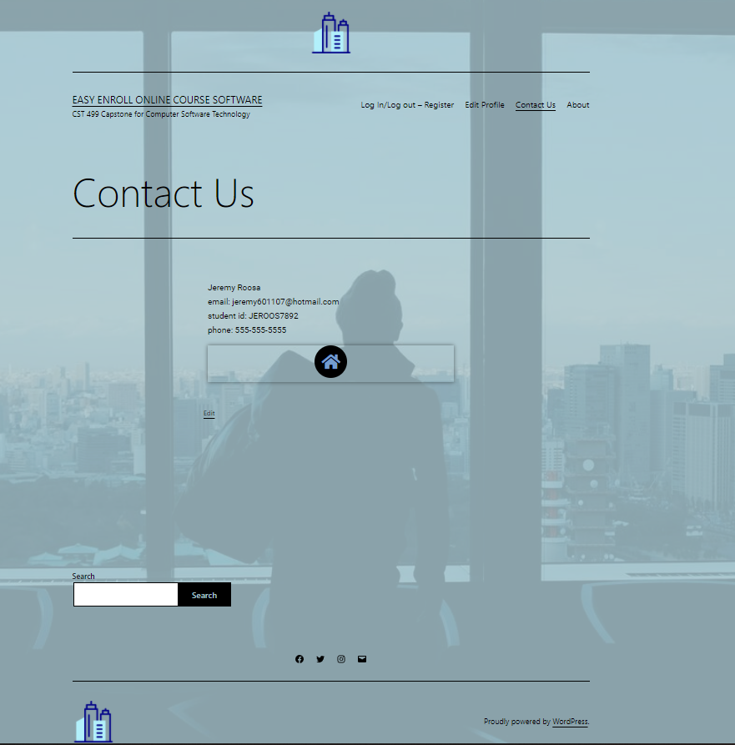

Figure 1.4 Logged-Out Page

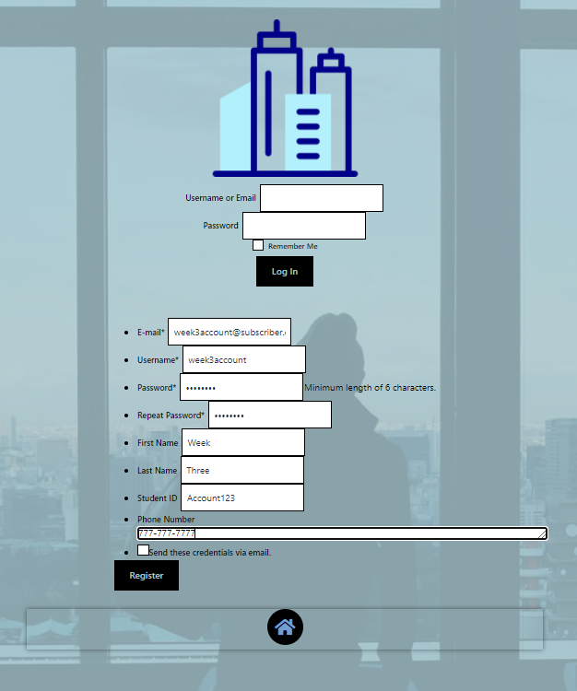

Figure 1.5 Logged-In page

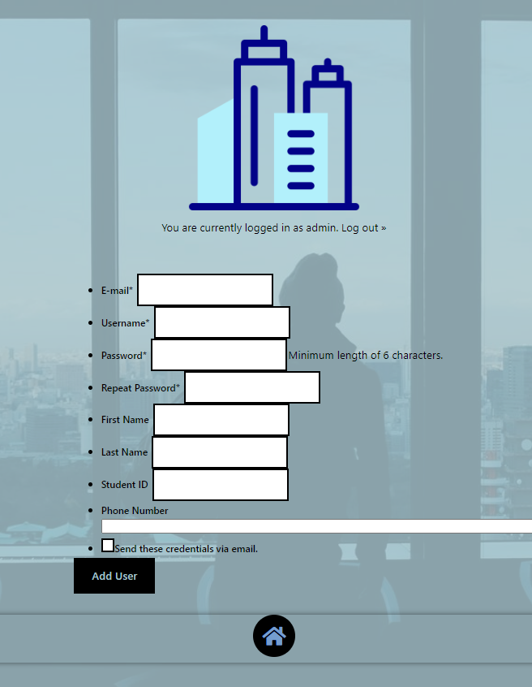

**Develop the registration page layout.**

Figure 1.6 Login/Registration Page

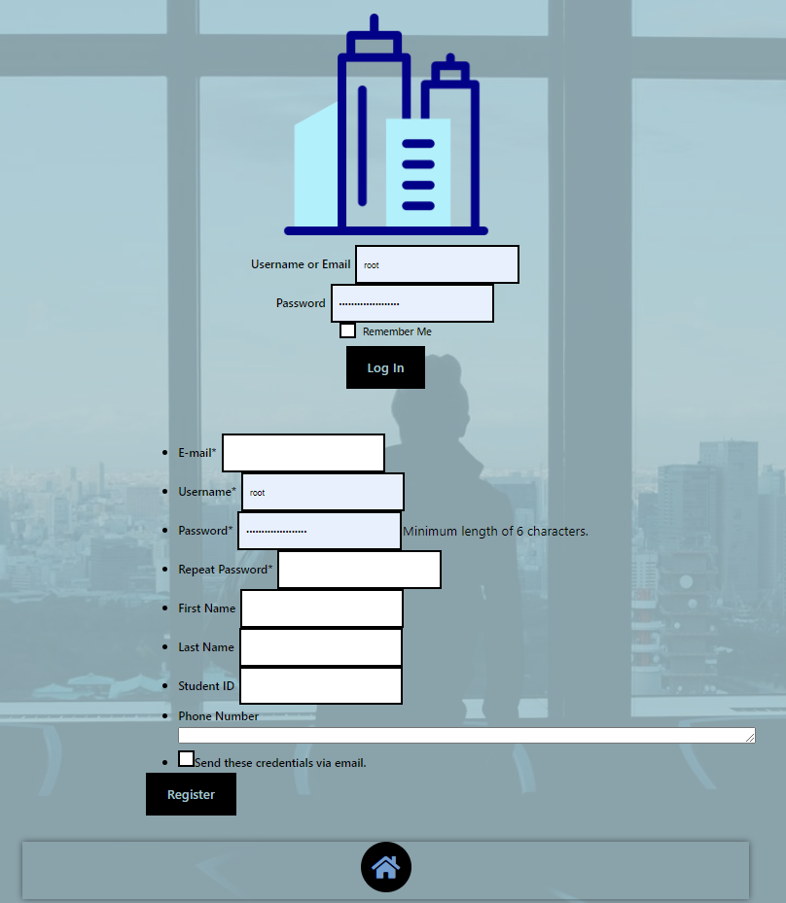

Figure 1.7 Populating Data in the Registration page

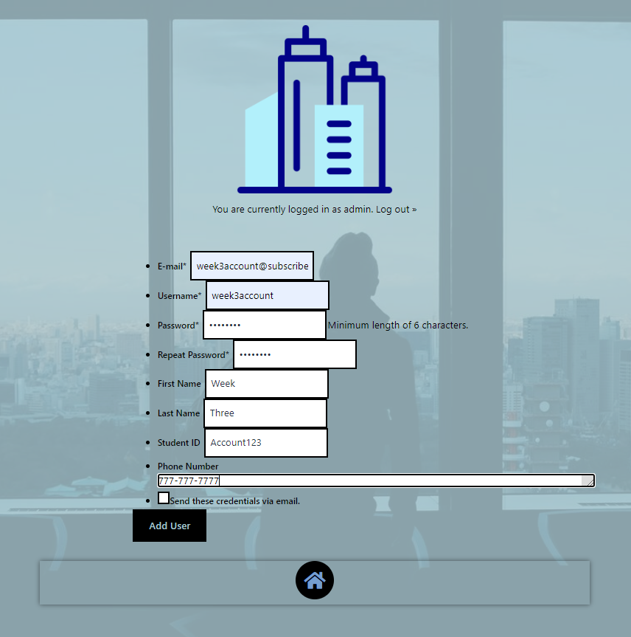

Figure 1.8 Account Creation Success page

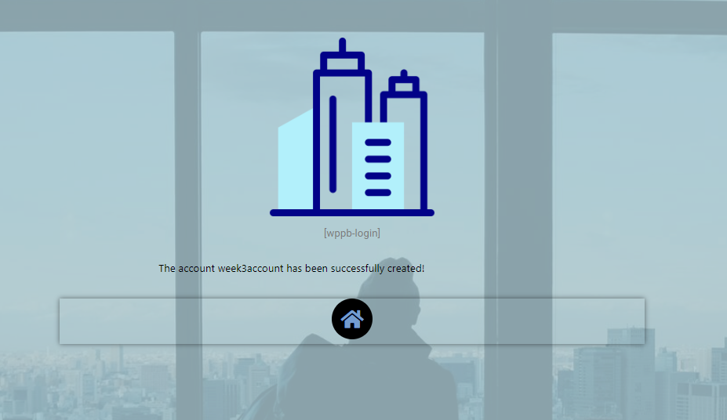

Figure 1.9 Edit Profile page



**Create the MySQL database and tables.**

Figure 2.1 Database Main page

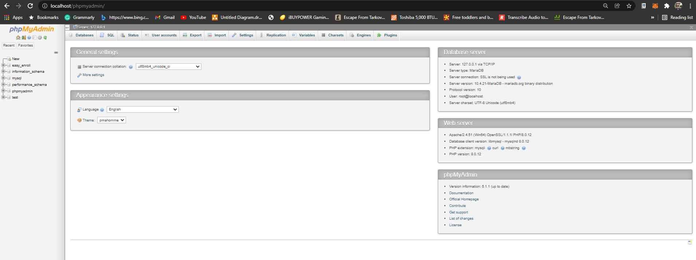

Figure 2.2 Easy_Enroll Database Overview

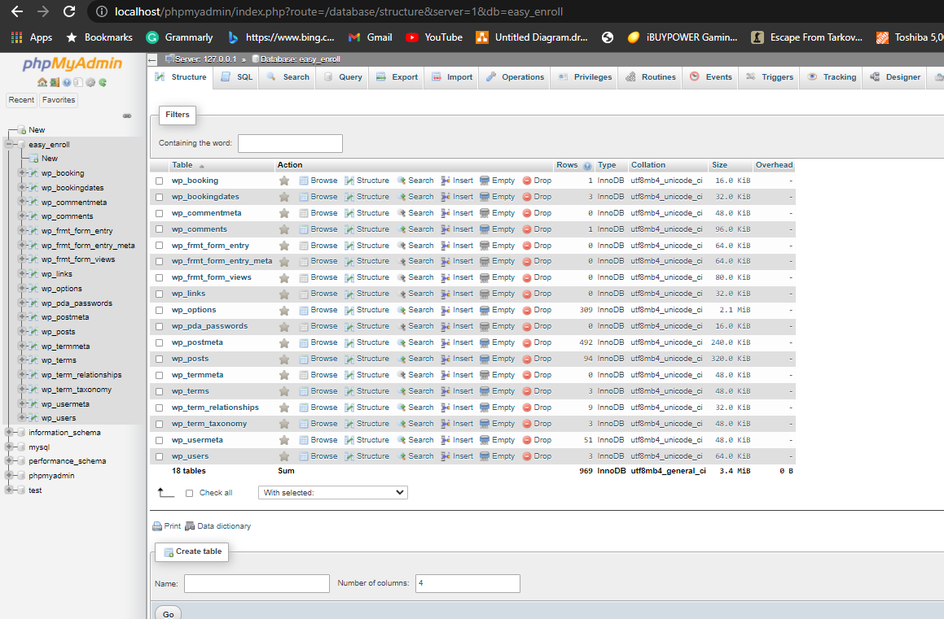

Figure 2.3 All Tables and Data



**Develop the table that saves the user information in the database.**

Figure 2.4 User_Meta Table Prior to Creating week3account

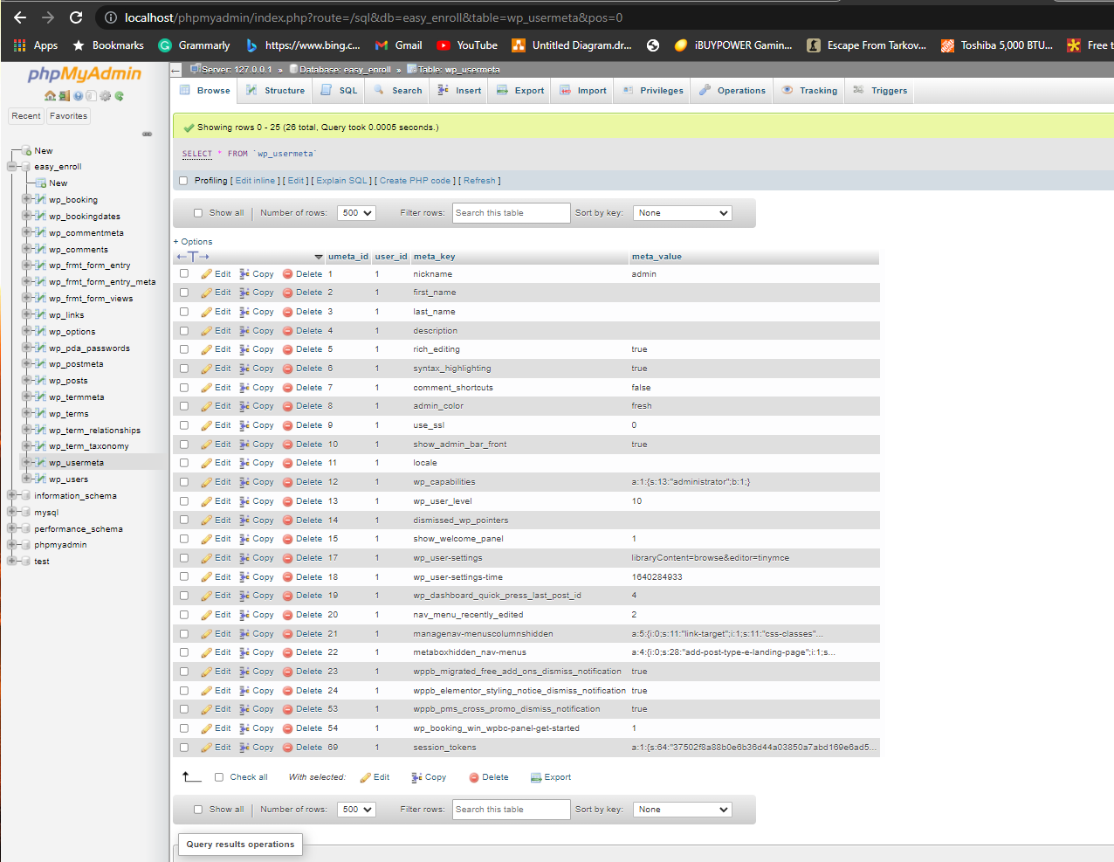

Figure 2.5 User_Meta Table After Creating week3account

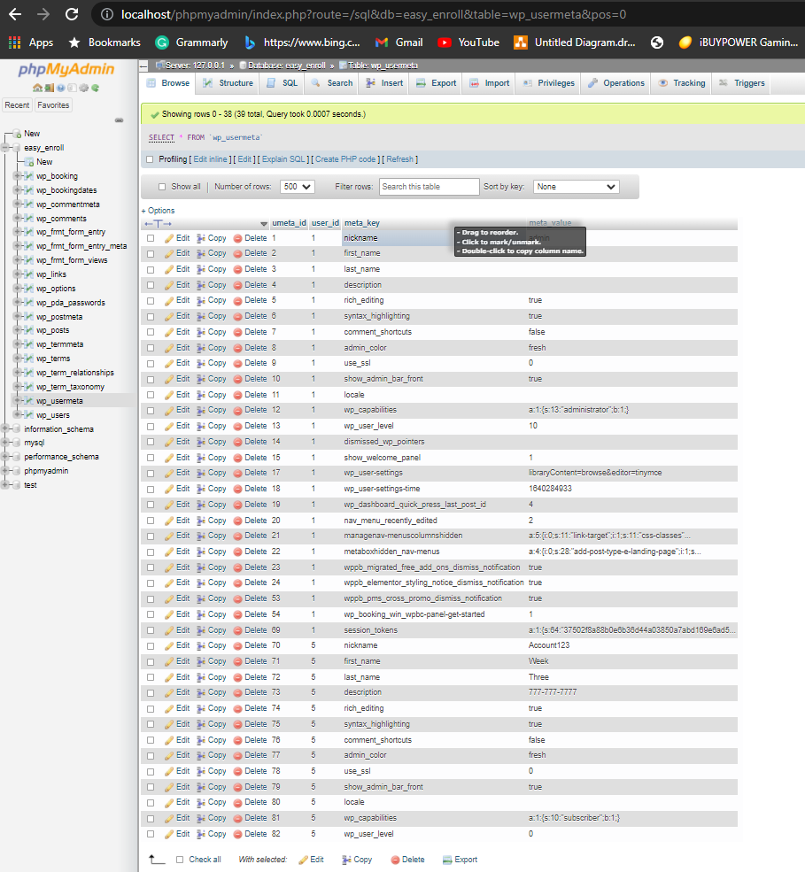

Figure 2.6 Users Table After Creating week3account

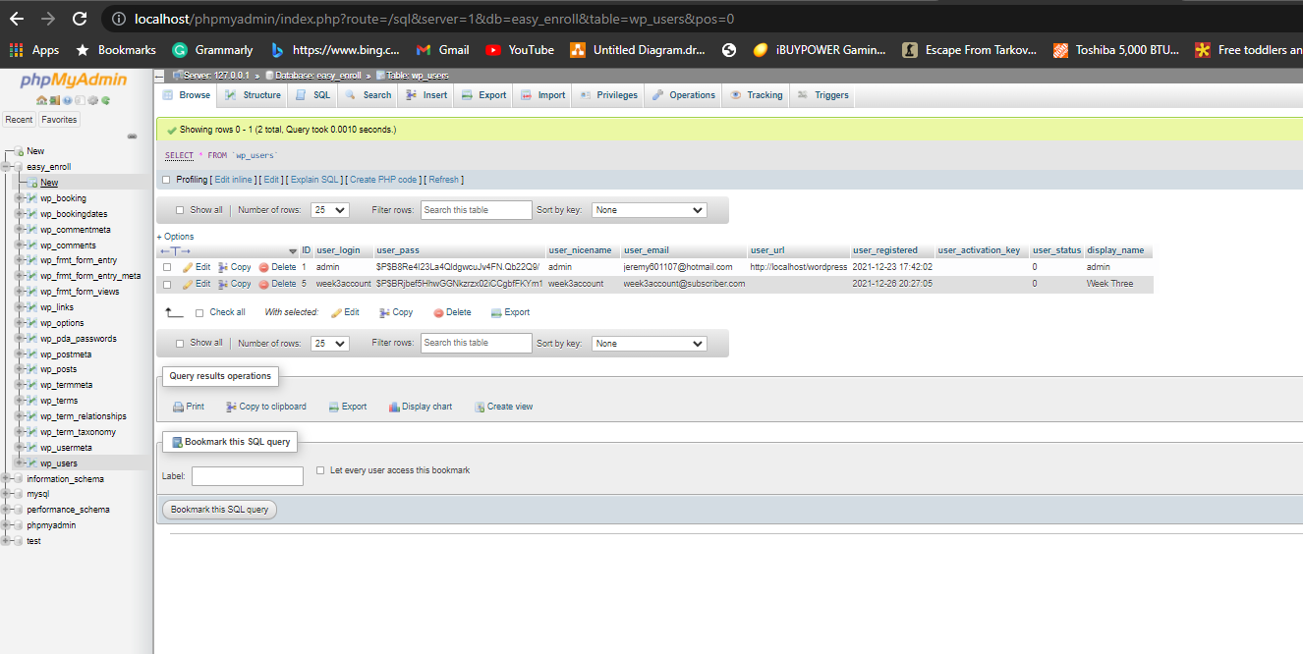

Figure 3.1 Login PHP Code 1

Figure 3.2 Login PHP Code 2

Figure 3.3 Login PHP Code 3

Figure 3.4 Login PHP Code 4

Figure 3.5 Login PHP Code 5

Figure 3.6 Login PHP Code 6

Figure 3.7 Login PHP Code 7

Figure 3.8 Login PHP Code 8

Figure 3.9 Login PHP Code 9

Figure 3.10 Login PHP Code 10

Figure 3.11 Login PHP Code 11

Figure 3.12 Login PHP Code 12

Figure 3.13 Login PHP Code 13

Figure 3.14 Login PHP Code 14

Figure 3.15 Login PHP Code 15

Figure 3.16 Login PHP Code 16

Figure 3.17 Login PHP Code 17

Figure 3.18 Login PHP Code 18

Figure 3.19 Login PHP Code 19

Figure 3.20 Login PHP Code 20

**Develop the registration page PHP source code.**

Figure 4.1 Registration PHP code 1

Figure 4.2 Registration PHP code 2

Figure 4.3 Registration PHP code 3

Figure 4.4 Registration PHP code 4

Figure 4.5 Registration PHP code 5

Figure 4.6 Registration PHP code 6

Figure 4.7 Registration PHP code 7

Figure 4.8 Registration PHP code 8

Figure 4.9 Registration PHP code 9

Figure 4.10 Registration PHP code 10

Figure 4.11 Registration PHP code 11

Figure 4.12 Registration PHP code 12

Figure 4.13 Registration PHP code 13

Figure 4.14 Registration PHP code 14

**References**

Aayushi, J., (2019, July 16). How to Run a PHP program in Xampp? Step by Step Guide | Edureka. Edureka. https://www.edureka.co/blog/how-to-run-a-php-program-in-xampp/

Petra, O., (2020). Metadata. Techterms.com. https://techterms.com/definition/metadata

Syed, B., (2019, September 23). Beginner’s Guide to WordPress Database Management with phpMyAdmin. WPBeginner. https://www.wpbeginner.com/beginners-guide/beginners-guide-to-wordpress-database-management-with-phpmyadmin/

Tsui, F., Karam, O., & Bernal, B. (2018). Essentials of software engineering (4th ed.). Jones & Bartlett Learning.

‌

‌

‌

‌